Exploratory Data Analysis of FIFA 2019 World Cup Players

Vinay Nagaraj

DSC530-T301 – Term Project

## Introduction

FIFA football World Cup is one of the most watched sports event in the world with more than half of the world’s population being its viewers. It is the biggest sporting event on the planet. It is an international association football competition contested by the senior men's national teams of the members of the *Fédération Internationale de Football Association* (FIFA), the sport's global governing body. This event is played every 4 years.

People around the world are crazy about this event that there would be discussions about who is the best player and each person defending their players, teams. People are awake all night to catch the matches live, then analyze every game, watch highlights, read articles, YouTube videos. It is a religion in some places. The economic crisis of Spain was forgotten, albeit for a few days, when they won the World Cup in 2010. Such is the craze.

## Statistical or Hypothetical questions

* What is the age of the youngest and oldest player to play the world cup that year?
* What is the weight of the lightest and heaviest player to play the world cup that year?
* What is the height of the tallest and shortest player to play the world cup that year?
* Football Positions of the players
* More Left foot or Right foot players
* Who are better defenders? Right foot players or Left.
* Who are better in Shooting? Right foot players or Left.
* What would be an average age of a Player if he has to master the skill of Defending & Shooting?

## Outcome of EDA

* What is the age of the youngest and oldest player to play the world cup that year?

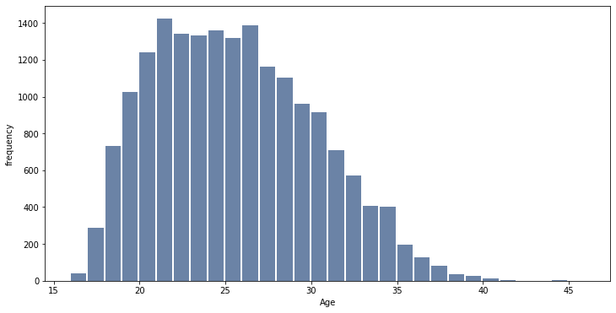

Based on the above histogram we can notice that there are 41 players who are 16 years old and 1 player who is 45 years old.

* What is the weight of the lightest and heaviest player to play the world cup that year?

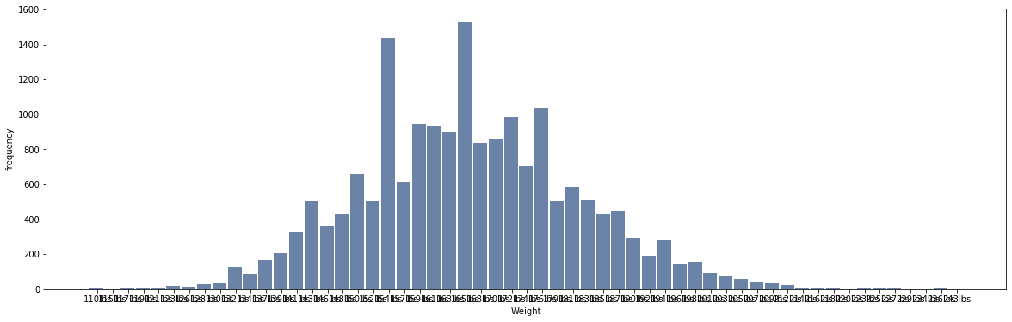

Based on the above histogram we can notice that the lightest player is 110lbs and the heaviest player is 243lbs.

* What is the height of the tallest and shortest player to play the world cup that year?

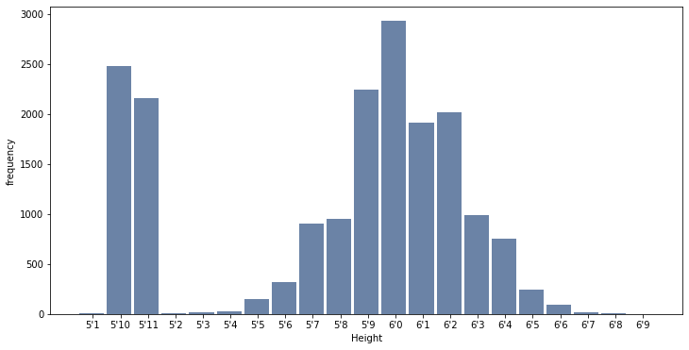

Based on the above histogram we can notice that there are 2 players who are 6’9 and 3 players who are 5’1.

* Football Positions of the players

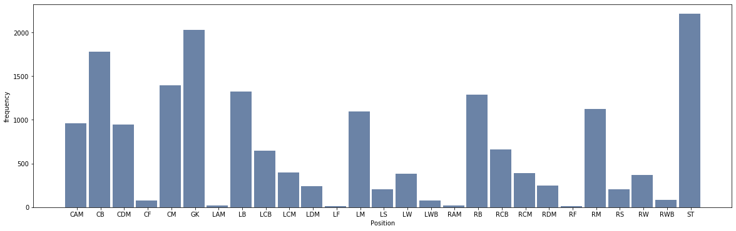

Based on the above Histogram we can notice that we have 2,212 players who are Strikers.

* More Left foot or Right foot players

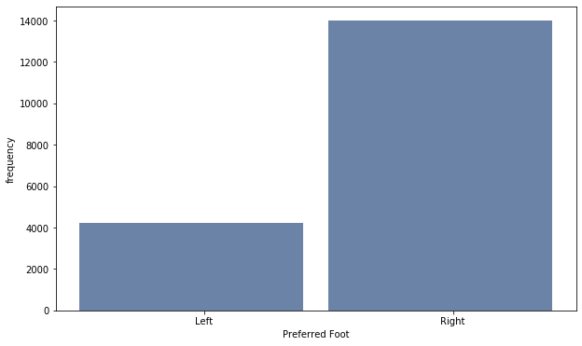

We have 4,211 players whose preferred foot is Left and 13,995 players whose preferred foot is Right.

* Who are better defenders? Right foot players or Left.

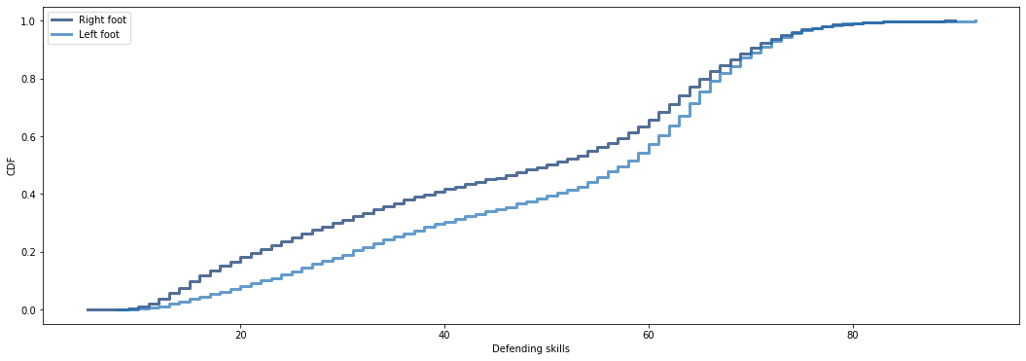

From the above CDF plot, the shape of the distribution clearly indicates that Left foot players are better in Defending than the Right foot players.

* Who are better in Shooting? Right foot players or Left.

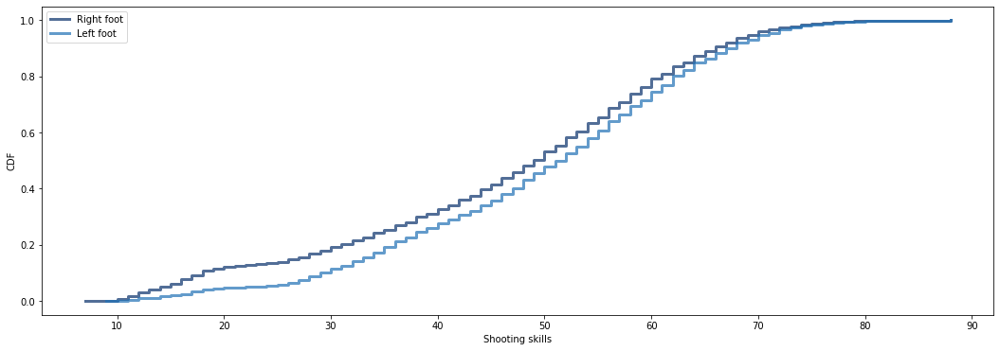

From the above CDF plot, the shape of the distribution clearly indicates that Left foot players are better in Shooting than the Right foot players.

* What would be an average age of a Player if he has to master the skill of Defending & Shooting?

As per our model, a player would be around 28.45 years to master the skill of Defending and Shooting.

## Observations

* The variables that I felt was missing and would have been nice to have were the Goals scored and Goals saved. That would have helped me quantify their performance much better.
* I selected this topic very early during the course, so when every week passed by I was trying to see how I could apply that concept with the dataset I had. It was a little challenging. I felt probably it would have been better if I could do my term project once I am aware of all concepts or if we were provided with a list of datasets we could pick one from on which all concepts could have been applied.

## References

Downey, A. B. (2015). *Think Stats:* Beijing: OReilly.

<https://www.kaggle.com/blurredmachine/fifa-2019-world-cup-dataset>